⎺⎺⎺⎺⎺⎺⎺⎺⎺⎺⎺⎺⎺⎺⎺⎺⎺⎺⎺⎺⎺⎺⎺⎺⎺⎺⎺⎺⎺⎺⎺⎺⎺⎺⎺⎺⎺⎺⎺⎺⎺⎺⎺⎺⎺⎺⎺⎺⎺⎺⎺⎺⎺⎺⎺⎺⎺⎺⎺  
  
The Cyndicate's: ezCharge Adapter  
For the Baofeng Charger.   
  
• Backing Plate x1:   
56mm/2.205in[ᴡ] x 21mm/.8265in[ʜ﻿] x 0.85mm/0.0335in[ᴅ]  
  
• Center Plate(s) x2:  
30mm/1.181in[ᴡ] x 21mm/.8265in[ʜ﻿] x 0.85mm/0.0335in[ᴅ] OR ⤾  
• Center Plate x1:  
30mm/1.181in[ᴡ] x 21mm/.8265in[ʜ﻿] x 0.85mm/0.0335in[ᴅ]  
  
• Conductive Tape:  
5mm/0.197in[ᴡ]  
  
• Thin Wire:  
≤18[ᴀᴡɢ]  
  
• Glue

⎼⎼⎼⎼⎼⎼⎼⎼⎼⎼⎼⎼⎼⎼⎼⎼⎼⎼⎼⎼⎼⎼⎼⎼⎼⎼⎼⎼⎼⎼⎼⎼⎼⎼⎼⎼⎼⎼⎼⎼⎼⎼⎼⎼⎼⎼⎼⎼⎼⎼⎼⎼⎼⎼⎼⎼⎼⎼⎼

1. Glue the two center plates together.  
2. Glue those plates to the middle of the backplate, with the bottom of all plates aligned, flat.  
3. Line up the 5mm conductive tape with the charging contact springs and tape one layer, vertically. From inside seam to inside seam they should be 15mm/0.5905in apart.  
4. Wrap the thin wire, 1 time, around the middle of both tape tracks.  
5. Wrap a few more layers of conductive tape over the wires, maybe 3-5 times.  
6. Wrap electrical tape around the middle to insulate the contact tracks from each other. You'll likely have to trim the side of the tape.  
  
That's it ❢❢  
  
Just place the backing plate behind the track rails in the charger and now it is very simple to place your radio in the charger for an easy full charge. Easy to pick it right up and go, without having to fumble with the feather-light factory charger.  
  
⎼⎼⎼⎼⎼⎼⎼⎼⎼⎼⎼⎼⎼⎼⎼⎼⎼⎼⎼⎼⎼⎼⎼⎼⎼⎼⎼⎼⎼⎼⎼⎼⎼⎼⎼⎼⎼⎼⎼⎼⎼⎼⎼⎼⎼⎼⎼⎼⎼⎼⎼⎼⎼⎼⎼⎼⎼⎼⎼  
  
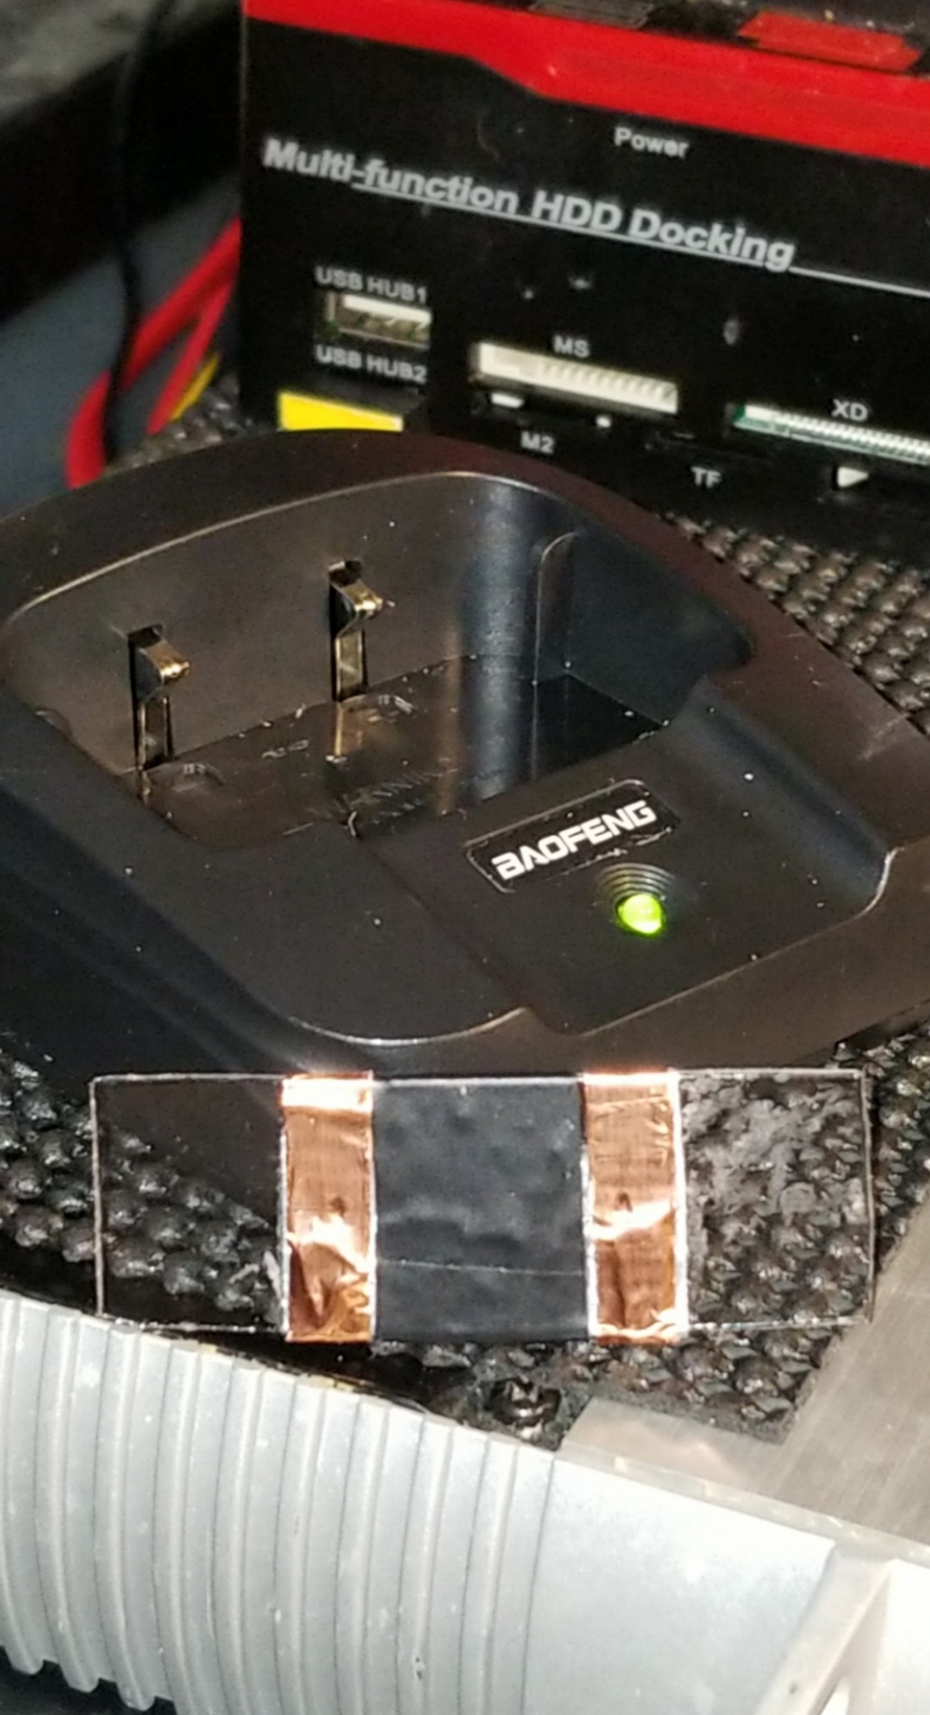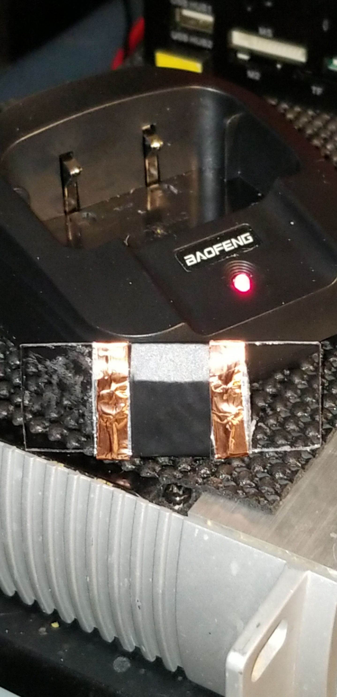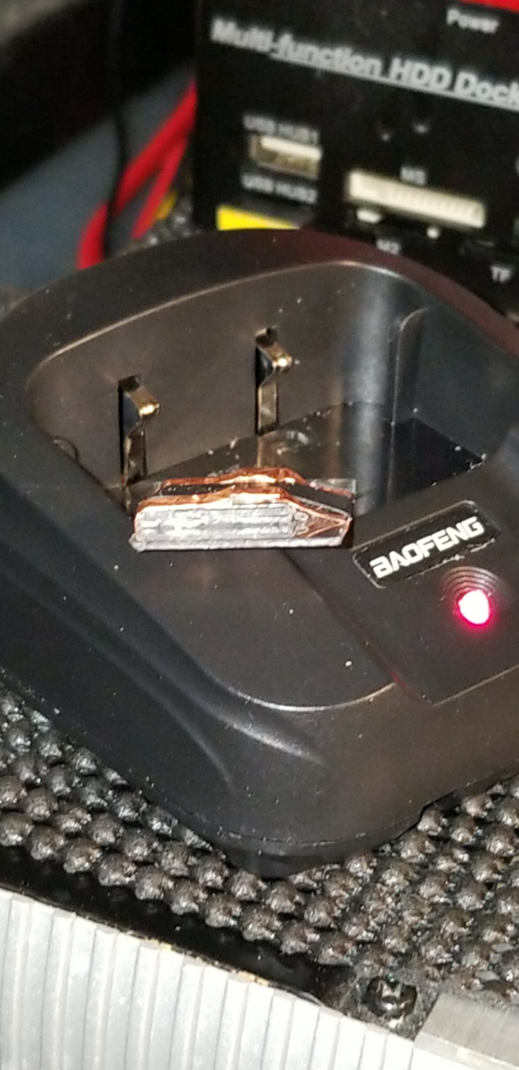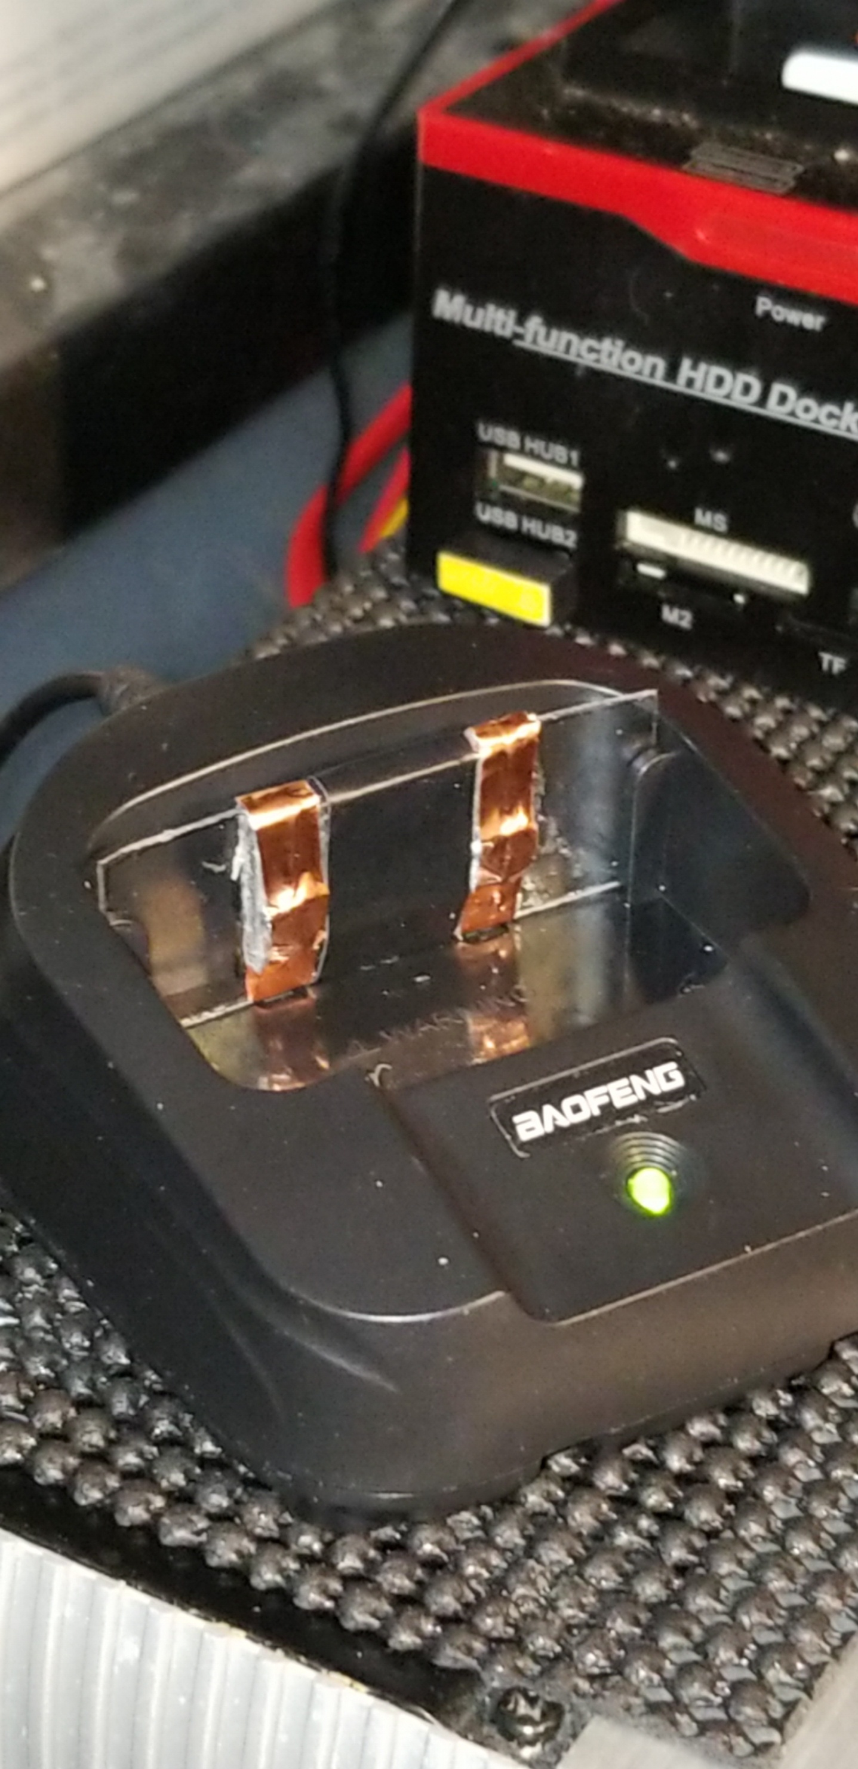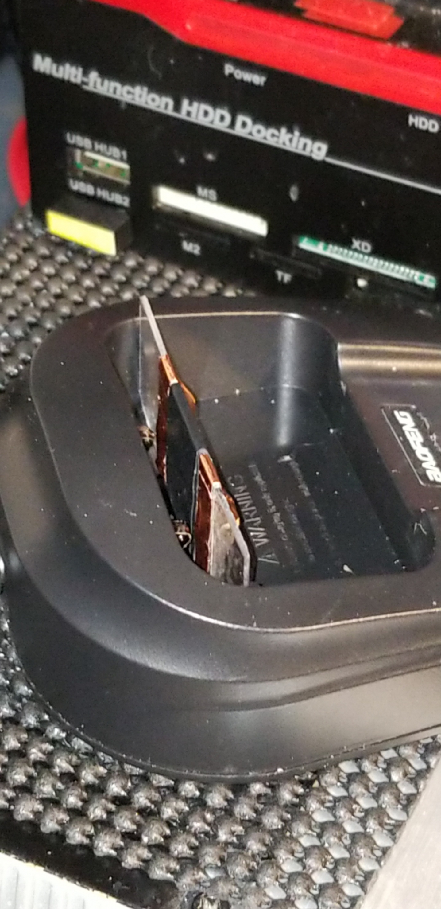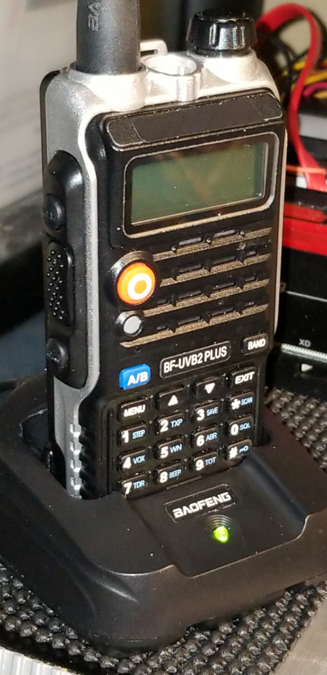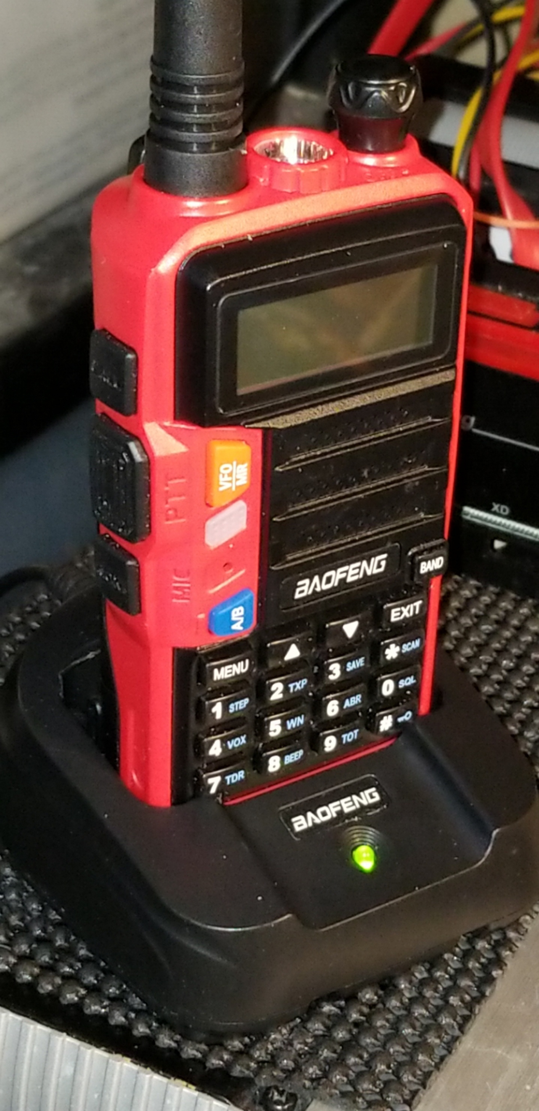  
  
‗‗‗‗‗‗‗‗‗‗‗‗‗‗‗‗‗‗‗‗‗‗‗‗‗‗‗‗‗‗‗‗‗‗‗‗‗‗‗‗‗‗‗‗‗‗‗‗‗‗‗‗‗‗‗‗‗‗‗

02:42:40AM on Jun/18/2019 ​​​ ​ ​​ ​​​​ ​​​ ␃